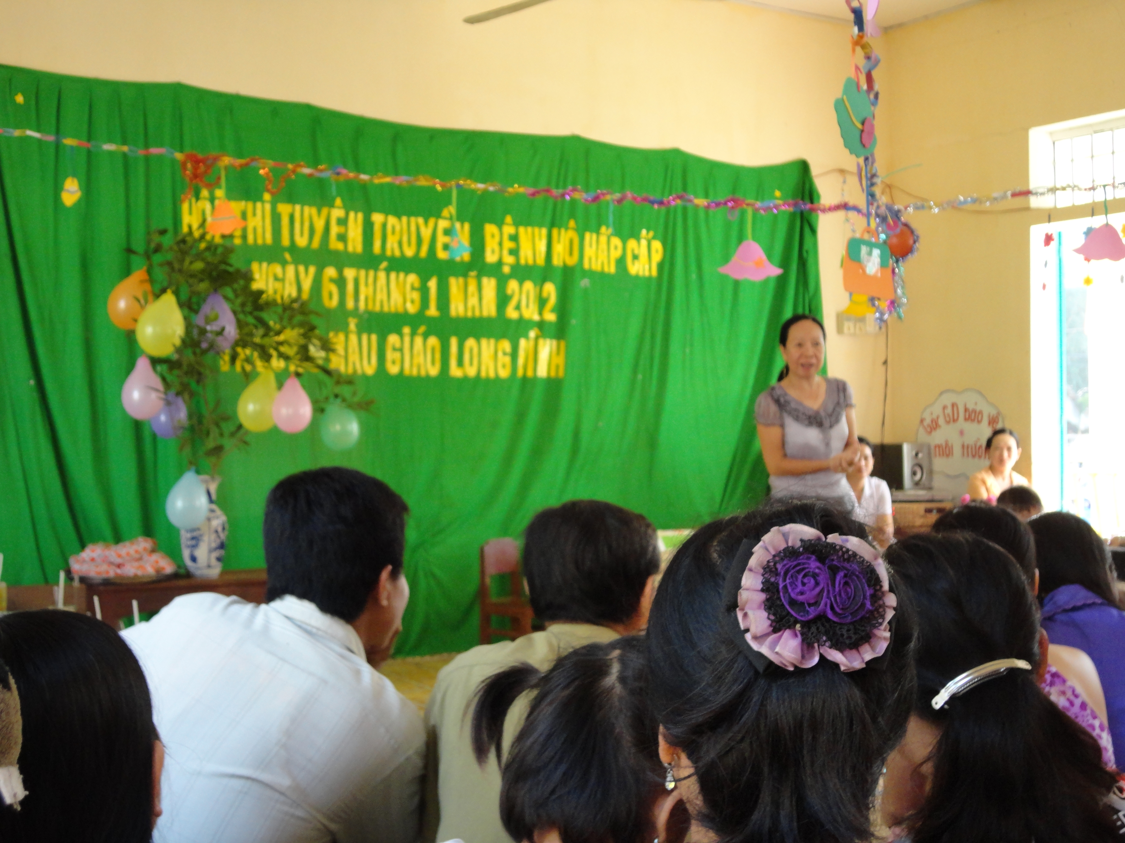

**1. FAMILY NAME:** Phan Thi Thanh

**2. FIRST NAME:** Trúc

**3. DATE OF BIRTH:** 11/04/1965

**4. PLACE OF BIRTH:** Mỹ Thuận-Vĩnh Long

**5. NATIONALITY:** Vietnamese

**6. EDUCATION:** Nurse Coure in Vĩnh Long 1983.

Physician Course in HCM City *1991.*

Druggist Course in Vinh Long 1995.

**7. LANGUAGES SKILLS:**  No

**8. COMPUTER SKILLS:** Word, Excel, Power Point

**9- Present Position:**  
  
Vice Director of Anh Duong Community Development and Support Center.  
  
**10- Years with the NGO:** From 2006 until now.  
  
**11. Key Qualification:**  
Community Development

School Health.  
Health Education  
Inclusive Education  
Oral Health Education  
  
**12. Professional Experience**:  
  
- 1983- 1988: Staff of Emergency Aid Department in Tam Binh Hospital, Vinh Long Province.

- 1992- 1994: Community health staff in Chau Thanh District, Dong Thap Province.

- 1996- 2005 : Drugstore staff in Long Phu commune health station, Tam Binh District, Vinh Long Province.end_of_the_skype_highlightin  
- From Oct, 2006 to present: Staff of Viet Nam Plus and Vice Director of Anh Duong Community Development and Support Center.

* **13. OTHER PROFESSIONAL EXPERIENCES:**  
  **14. Tài liệu tham khảo:**  
  Bernard Kervyn: [bernard.kervy@gmail.com](mailto:bernard.kervy@gmail.com) . Tel: 08 8940797 & 0913 105189
* Tài Đại Thành, Director of Anh Duong Center. Tel: 072 822437 & 0913 876138
* Đại học Tôn Đức Thắng: [pktrad@yahoo.com](mailto:pktrad@yahoo.com) .

**15. ADDRESS :**

* Phan Thị Thanh Trúc.

Anh Duong Community Development and Support Center

36 CMT8 Street, Long My district, Hau Giang Province

Fax & tel.: 84- 07113 871869.

Email: anhduong.longmy@ gmail.com

end_of_the_skype_highlighting